a clear and concise summary of the lecture note “Storage Hierarchy” (dbms2526_storage12.pdf):

📌 Summary: Storage Hierarchy in DBMS

✅ 1. Storage Hierarchy Overview
Data in a DBMS is stored across different storage levels depending on speed, cost, reliability, and volatility:
Storage Type | Example | Speed | Persistent? | Cost
Primary | CPU cache, Main memory | Very fast | No | Very high
Secondary | HDD, SSD | Slower | Yes | Moderate/Low
Tertiary | Magnetic tape, optical disk | Very slow | Yes | Very low

✅ 2. Primary Storage
- Includes main memory (RAM) and CPU cache.
- Very fast access, byte-level addressing.
- Volatile – data is lost when power is off.
- Limited capacity (defined by address size like 32-bit = 2³² bytes).

✅ 3. Secondary Storage
- Uses Hard Disk Drives (HDD) or Solid State Drives (SSD).
- Non-volatile & high capacity (terabytes).
- Access is done in blocks (e.g. 4 KB), not single bytes.
- Much slower than main memory.
Feature | HDD | SSD
Speed | 100–280 MB/s | 3,000–7,000 MB/s
Latency | 1–30 ms | 10–100 µs
Cost | Cheap per TB | More expensive per TB
Reliability | Mechanical (wear & tear) | No moving parts

✅ 4. Tertiary Storage
- Used for archiving or database logs (backups, journals).
- Media include tapes, optical discs.
- Very cheap per GB, but extremely slow access (manual or robotic loading).

✅ 5. Why I/O is a Bottleneck
- CPU can perform 1,000,000 instructions in the time of one disk I/O.
- Only blocks (not individual bytes) are read/written between main memory and disk.
- DBMS must minimize disk access and use strategies like:
  - Buffering frequently used blocks.
  - Storing related blocks physically close.
  - Using I/O-efficient algorithms.

✅ 6. Sorting Example – Importance of I/O Optimization
Problem setup:
- File with 10⁷ records, block size 4 KB, memory stores ≈12,800 blocks.
- To sort this large data, in-memory sort isn’t enough.
Solution: Two-Phase Multiway Merge Sort (2PMMS)
Phase 1 – Sorting:
- Load as many blocks as possible into memory.
- Sort them and write sorted “runs” to disk.
Phase 2 – Merge:
- Read one block from each sorted run.
- Merge records into final sorted file using buffers.
Cost:
- File read + write in Phase 1 = 2 * 250,000 I/Os
- File read + write in Phase 2 = 2 * 250,000 I/Os
- Total = 1,000,000 I/Os

✅ 7. Key Takeaways
- Disk I/O is far more expensive than computation → DBMS minimizes it.
- Efficient algorithms like merge sort are adapted for disk-based systems.
- Storage hierarchy design is foundational for DBMS performance.
- SSDs offer speed; HDDs offer cost efficiency—both used in modern systems.

✅ 📘 Practice Questions – Storage Hierarchy & File Management in DBMS

1️⃣ Theory / Conceptual Questions
- What is the difference between primary, secondary, and tertiary storage in terms of:
  - Speed
  - Volatility
  - Cost per GB
  - Typical use cases in DBMS?
- Why do database systems use secondary storage instead of keeping all data in main memory?
- Explain why data is transferred in blocks and not in bytes between disk and main memory.
- What are seek time, rotational latency, and transfer time in HDDs?
- Why is I/O considered the bottleneck of database systems?
- What is the role of buffer management in reducing disk I/O?
- Explain how SSDs differ from HDDs in terms of structure, performance, and reliability.
- Define:
  - Access time
  - Block
  - Page
  - Buffer

2️⃣ Numerical / Calculation Questions
- Memory Addressing
A system uses 32-bit addressing. How many bytes of memory can be addressed?
What about a 64-bit address?
- Block Calculation
A file contains 1,000,000 records, each of size 100 bytes.
Block size is 4 KB.
  - How many blocks are needed to store the file?
  - If reading one block takes 10 ms, how long to read the entire file?
- Time Comparison: Memory vs Disk
  - Main memory access = 100 ns
  - Disk access = 10 ms
How much slower is disk compared to main memory?
- Sorting Cost – Two-Phase Multiway Merge Sort
You have:
  - File size: 100,000 blocks
  - Memory buffers: 500 blocks
Calculate total number of I/Os for sorting using 2-pass merge sort.

3️⃣ Advanced / Application Questions
- Describe the two phases of Two-Phase Multiway Merge Sort (2PMMS) and explain why it is I/O efficient.
- Suppose you have a file too large to fit into memory. How does a database sort such data without loading the entire file at once?
- Why is it beneficial to keep related blocks physically close on disk?
- What is sequential access vs random access?
Why is sequential access preferred in DBMS algorithms?
- You are given a database system running on SSD. Would you still use external sorting techniques? Why or why not?
- Explain why caching policies like LRU (Least Recently Used) are important in buffer management.
- In what ways can a DBMS reduce disk I/O operations?

✅ Bonus: Challenge Question
A file has size 5 GB. Block size is 4 KB. Memory holds 10,000 blocks.
a) How many blocks does the file have?
b) Can it be sorted in 2-pass merge sort? Why or why not?
c) If no, how many passes are needed?

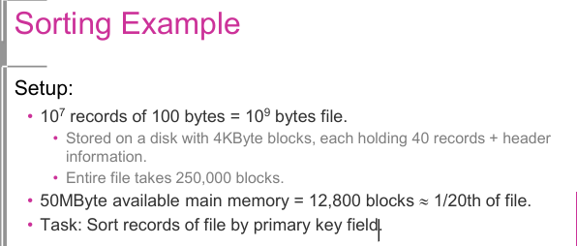
how we get “50 MB = 12,800 blocks ≈ 1/20th of the file” using the numbers in the example.

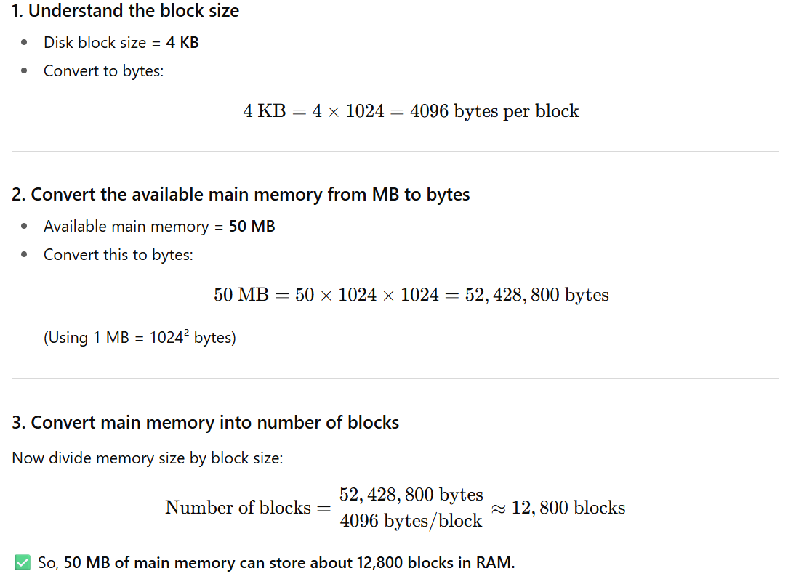
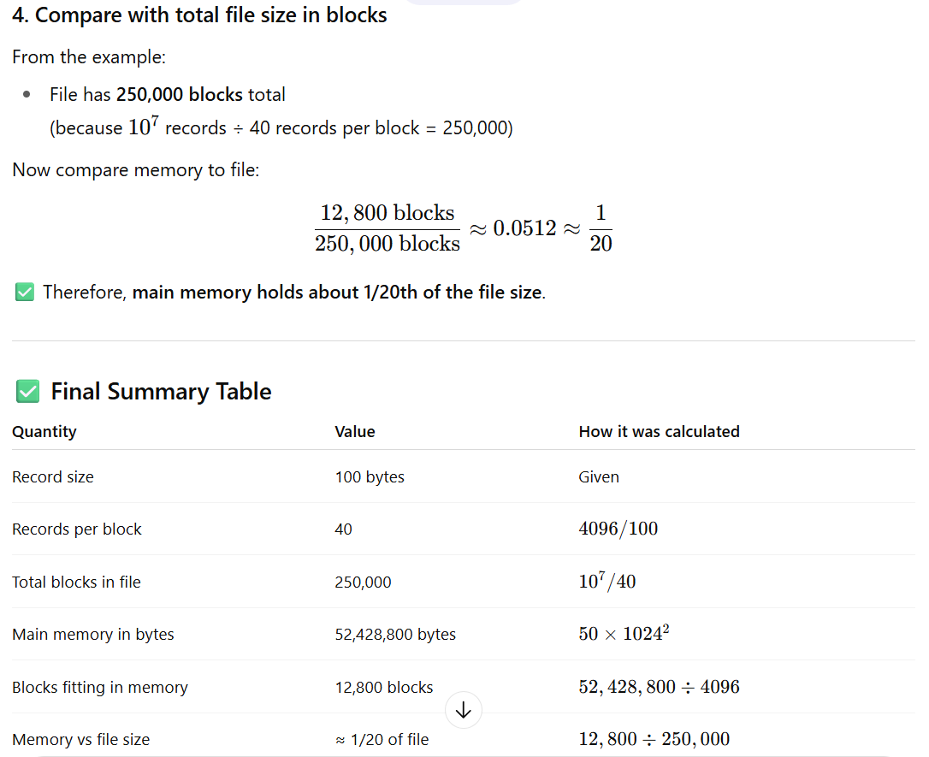
two more exercise-style examples similar to the sorting scenario.

✅ Example 1 – Sorting with Different Block and Memory Sizes
Setup:
- Total number of records = 5 × 10⁶
- Record size = 200 bytes
- Disk block size = 8 KB = 8192 bytes
- Records per block = 8192 ÷ 200 ≈ 40
- Total blocks in file = 5,000,000 ÷ 40 = 125,000 blocks
- Available main memory = 100 MB
- Main memory in bytes = 100 × 1024² = 104,857,600 bytes
- Main memory in blocks = 104,857,600 ÷ 8192 ≈ 12,800 blocks
Questions:
- How many blocks does the file occupy on disk?
- How many blocks of the file can fit into main memory at a time?
- What fraction of the file fits into memory?
- Is this enough to sort the file in two-pass external merge sort?

✅ Example 2 – Large File, Small Memory
Setup:
- Total number of records = 2 × 10⁸
- Record size = 50 bytes
- Disk block size = 4 KB
- Records per block = 4096 ÷ 50 ≈ 81
- Total blocks in file = 200,000,000 ÷ 81 ≈ 2,469,136 blocks
- Available main memory = 20 MB
- Main memory in bytes = 20 × 1024² = 20,971,520 bytes
- Main memory in blocks = 20,971,520 ÷ 4096 ≈ 5120 blocks
Questions:
- How many blocks are needed to store the full file on disk?
- How many blocks can fit into available main memory?
- What percentage of the file fits into memory?
- Is a two-pass sort possible? If not, estimate how many merge passes are needed.

